Physics Game Research – Michael Curtis

**Rocket League**

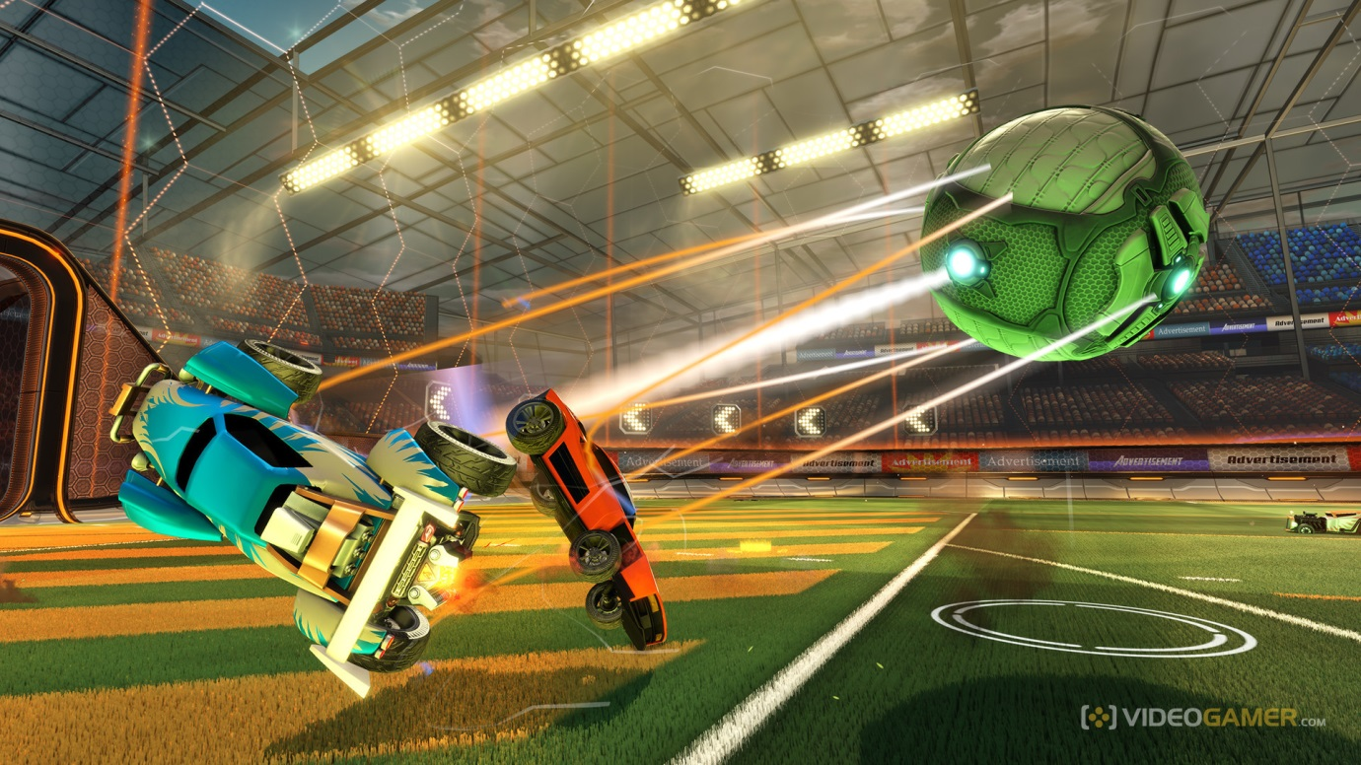

Rocket League is a great example of how simple mechanics work towards creating a game of depth supported greatly by the variety of human opponents which keep the game fresh and playable.  
The concept of hitting the ball and trying to get it into a goal is very intuitive so players can pick it up very easily. This is a game that is easy to learn and hard (or due to the massive player base and huge variety in opponent: impossible) to master.

What can we pull from it?

* Easy to learn – Hard to Master  
  This is part of the brief anyway but Rocket League shows how using concepts that people understand so well (Like how a football interacts when hit with different forces and in different angles) reduces the need to throw swarms of instruction at potential players in order for them to learn to play.
* Human Opponents  
  The fact that human opponents are so varied in skill and experience at every given game means that a symmetrical game like Rocket League can be made indefinitely fresh and fun to play (and difficult to master) as long as there are people playing the game that haven’t been faced before. While the need for an adversarial game means this will be included in the game regardless it is important to ensure different match ups of play testers when designing the game to make certain that the game caters for different players with different mind-sets and strategies so that different opponents are able to challenge players in different ways through the same game.

**Cut the Rope**

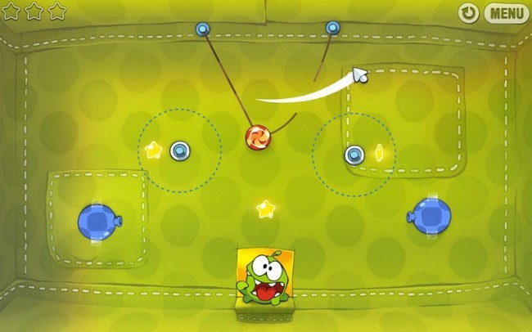

Cut the Rope uses gravity and momentum as its physics components. Players are presented with a puzzle in which they must get food to a creature. The food cannot be interacted with but can be grabbed by ropes and is affected by both momentum and gravity which are manipulated by the player so that by cutting the ropes that are attached to the food in good order and timing the food ends up with the creature.

* Zen-Like Focus  
  The puzzle of the game means people may fail many times before they succeed. Because of this players can get into a “Zen-Like focus” where they zone into the game and begin ignoring events unfolding around them in the real world while they try to solve the puzzle.  
  This sort of behaviour cannot be perfectly replicated with local multiplayer as players should always be aware of the person they are playing with and both would have to agree to play again when one of them loses. But the core element of concentration on a difficult puzzle could be pulled across to an extent and provides an interesting avenue for adversarial local multiplayer.

**Screenshots**

Psyonix. (2015). *Rocket League Screenshots.* Available: https://www.videogamer.com/games/rocket-league/screenshots. Last accessed 27/01/2017.

Toomky Games. (2011). *Cut the Rope.* Available: http://toomkygames.com/download-free-games/cut-the-rope. Last accessed 27/01/2017.